Chapter 11: Sequences and Series

11-1 Types of Sequences

Sequence: is an ordered set of numbers which could be defined as a function whose domain (x-values) consists of consecutive positive integers and the corresponding value is the range (y-values) of the sequence.

Term number: is an ordered set of numbers which could be defined as a function whose domain (x-values) consists of consecutive positive integers.
Term: the corresponding value (the range y-value) of the sequence
Finite: a sequence with a limited number of terms
Infinite: a sequence with an unlimited number of terms
Arithmetic sequence: a sequence in which a constant d (common difference) can be added to each term to get the next term.
Common difference: the constant difference, usually denoted as d
Geometric Sequence: a sequence in which a constant r can be multiplied by each term to get the next term

Common ratio: the constant ratio, usually denoted by r.

11-2 Arithmetic sequence:

Arithmetic Mean: the average between 2 numbers

11-3 Geometric Sequence:

Geometric Mean: the term between two given terms of a geometric sequence as defined by the following formula:

11-4 Series and Sigma Notation

Arithmetic series: The sum of the terms of an arithmetic sequence.
Geometric Series: The sum of the terms of a geometric sequence.

Sigma: A series can be written in a shortened form using the Greek letter (Sigma)
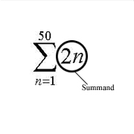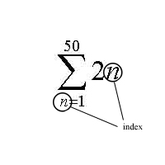

11-5 Sums of arithmetic and geometric series

Sum of an Arithmetic series:
, or

Sum of a geometric series:

11-6 Infinite Geometric Series

Theorem: an infinite geometric series is convergent and has a sum “S” if and only if its common ratio, r meets the following condition: | r | < 1

If our infinite series is convergent (| r | < 1), we can calculate its sum by the formula:

11-7 Binomial Expansions and Powers of Binomials

Binomial expansion:

You can use Pascal’s Triangle to find the coefficients of the expansion.

11-8 The General Binomial Expansion

The Binomial Theorem: for any binomial (a + b) and any whole number n, then =

Combinations:

Factorial:

To find the rth term of a binomial expansion raised to the nth power, use the following formula:

Which is the same as:

Thanks to my T.A., Jovanna a.k.a. “JT” for creating this review sheet.

