Chapter 12

12-1 Angles and Degree Measure
Initial Side: the ray that you start with when creating an angle.
Terminal Side: the ray where the rotation ends.
Standard Position: an angle where the initial side starts on the positive x-axis.
Positive Angles: are created by a counterclockwise rotation
Negative Angles: are created by a clockwise rotation
Quadrantal Angle: when the terminal side lies on the x-axis or y-axis.
Coterminal: when the terminal sides of two standard position angels coincide (are the same line)
(The angle with conterminal sides)

One minute (1’) can be divided into 60 seconds (60’’), or 1’=60’’. Use the following summary for degrees, minutes, and seconds:

12-2 Trigonometric Functions of Acute Angles
The six trigonometric Ratios in a Right Triangle involving one angle and two sides.
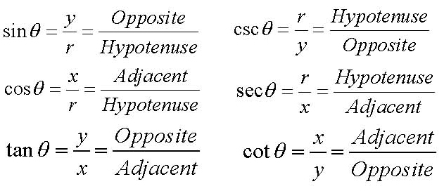
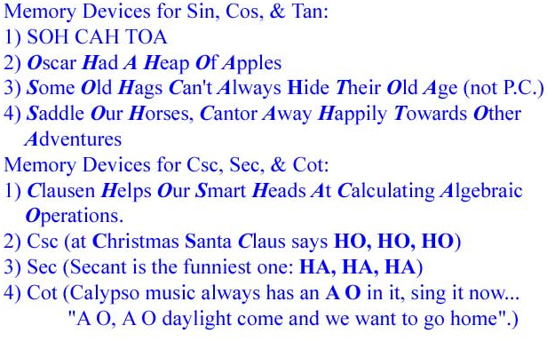
Trigonometric Identity: is an equation involving trigonometric functions of an anglethat is true for all values of .

Complimentary Angles: are angles whose sum is

Co-function Identities
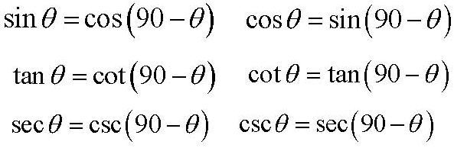
Special Right Triangles from Geometry
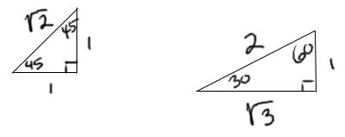
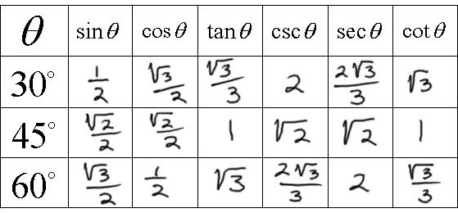

12-3 Trigonometric Functions of General Angles
The following Trigonometric Functions have positive values in the Quadrants shown.
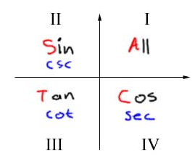
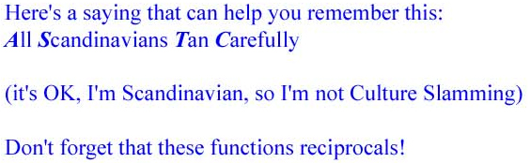
Don’t forget that the reciprocals of these functions are positive too.

Reference Angle: is an acute angle formed by the terminal side and the x-axis.

12-4 Values of Trigonometric Functions

This section covered using your calculator to find the values of Trig. Functions.

12-5 Solving Right Triangles
Solving the triangle: is finding the measures of all sides and all angles in a triangle.
Angle of elevation: is found by the line of sight looking horizontally out to the horizon and then looking up at an object.
Angle of depression: is found by the line of sight looking horizontally out to the horizon and then looking down at an object.

12-6 The Law of Cosines
The Law of Cosines is used to solve triangles that are not right triangles.
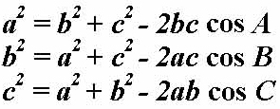

12-7 The Laws of Sines
The Law of Sines is used to solve triangles that are not right triangles.
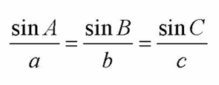

12-9 Areas of Triangles: Law of Sines, Hero’s Formula

The Law of Sines (Triangle Area Formula): is best suited to triangles where you know the measures of two sides and the included angle (SAS) and wish to calculate the area. The formulas are:
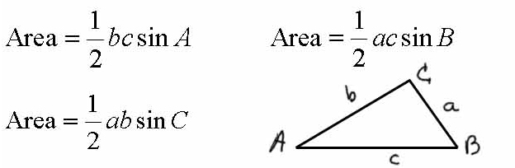

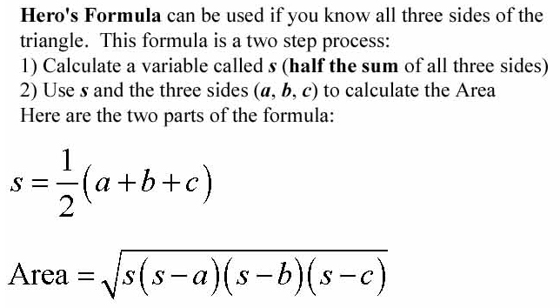

Thanks to my T.A., Jovanna “JT” for making this review sheet.

