Chapter 16 Matrices and Determinants

16-1 Definition of terms
Matrix: is a rectangular array of numbers enclosed by square brackets (plural of matrix is matrices).

Elements: objects in a matrix.

Dimensions: are determined by the number of rows (horizontal) and columns (vertical).
(Rows before columns: RC Cola)

Square matrix: is a matrix that has the same number of rows and columns.

Zero Matrix: is a matrix where all the elements are zeros.

16-5 Calculating Determinants Using the Definition
Determinant: only square matrices have determinants. This is a real number associated with square matrices (definitions to follow).

det A: |A|

Order: the number of elements in any row or column (since the number of rows and the columns is the same)

The determinant of matrix 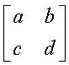is denoted by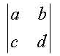

The det A is the same as |A|.

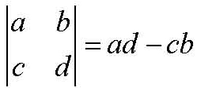

The determinant of a 3 x 3 matrix B, det B is defined as follows:
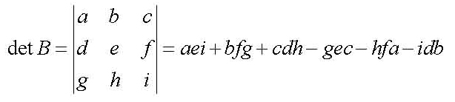

16-7 Determinants: Expansion by Minors

Minor of an element: The determinant formed by “deleting” or “hiding” the row and column that contains the elements.

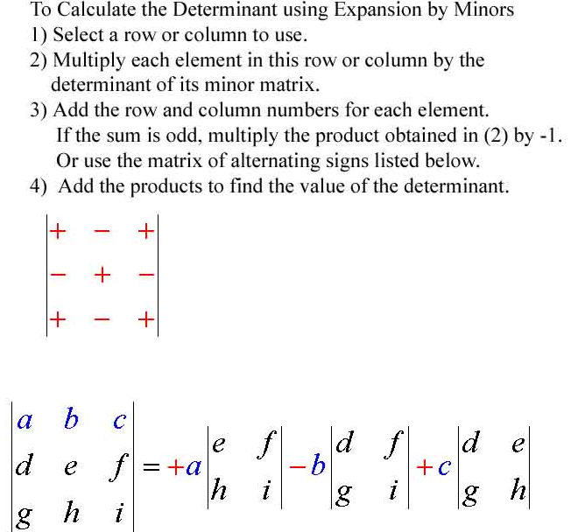

16-9 Part 1 Cramer’s Rule (2 Eqs. & 2 Vars.)
Cramer’s Rule: used to solve systems equations.

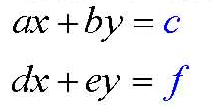
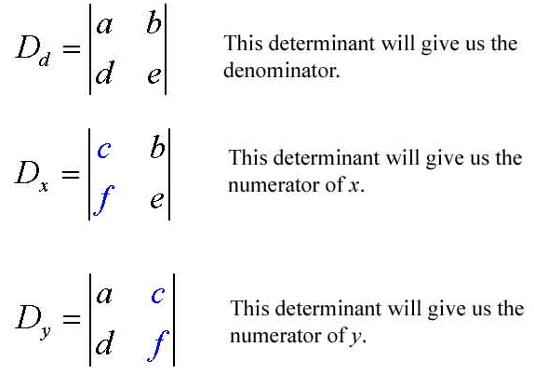
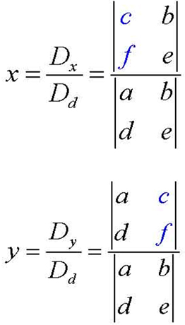

Inconsistent or Dependent
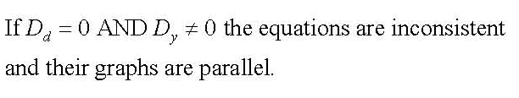
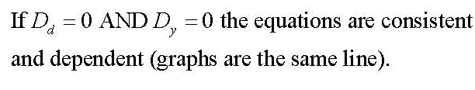
16-9 Cramer’s Rule Part 2 (3 Eqs. & 3 Vars.)
Solve Systems with 3 equations and 3 variables
