Chapter 8 Variation and Polynomial Equations

8-1 Direct Variation and Proportion
1) y varies directly with x
2) y varies with x
3) y is directly proportional to x
4) y is proportional to x

8-2 Inverse and Joint Variation
1) y varies inversely as x
2) y is inversely proportional to x

Joint Variation is two or more direct variations.
Ex. y varies jointly with x and z.

y = k • x • z

8-3 Dividing Polynomials
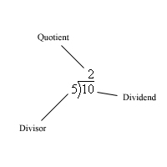

8-4 Synthetic Division

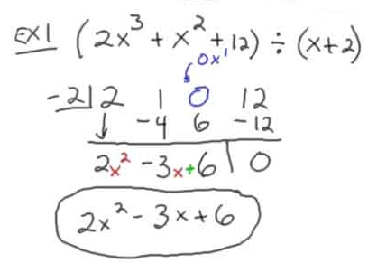

8-5 The Remainder and the Factor Theorems

Remainder Theorem: If P(x) is a polynomial of degree n (n>0), then for any number r, , where Q(x), is a polynomial of degree n-1. For the polynomial P(x), the function value P(r) is the remainder when P(x) is divided by x-r.

Factor Theorem: A polynomial P(x) has (x-r) as a factor if and only if r is a root of the equation P(x) = 0

8-6 Some Useful Theorem For Solving Polynomial Equations

The Fundamental Theorem of Algebra (Carl Gauss)
For every polynomial of degree n > 1(with complex coefficients) there exists at least one linear factor.

Another Theorem by Carl Friedrich Gauss
Every polynomial of degree n > 1, (with complex coefficients) can be factored into exactly n linear factors.

Once we have these n linear factors, we can use the Zero Product Property to find the n roots or solutions of the polynomial.

Conjugate Root Theorem for Complex Roots
If a polynomial P(x) of degree greater than or equal to 1 (with real coefficients) has a complex number as a root a + bi, then its conjugate a – bi is also a root

8-7 Finding Rational Roots

Rational Root Theorem
…where all coefficients are integers.
Find a rational number c/d, where c and d are relatively prime. For c/d to be a root of P(x), c must be a factor if the constant, c and d must be a factor of the leading coefficients.

Possible Rational Roots:

